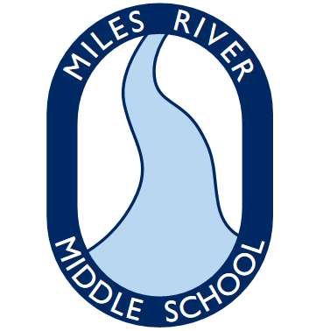
Integrated Arts Supplies
(Art, Drama, Health/Wellness, Music – all grades)
Miles River Middle School

You will need the following items for your IA classes:

-One 1” 3 ring binder (any color)
-One 2-pocket folder
-Lined paper-3 hole punch – 1 pkg
-Three #2 pencils

