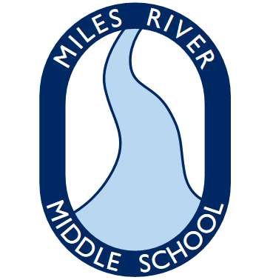
Grade 7 Supplies
Miles River Middle School
Hamilton, MA

Welcome to Grade 7
To get ready for the 2019-2020 school year, please gather the following supplies:

Required Supplies for School
- 5 good quality binders (1” ring; one must be white for homework)
- 250 count, 3 hole punch paper
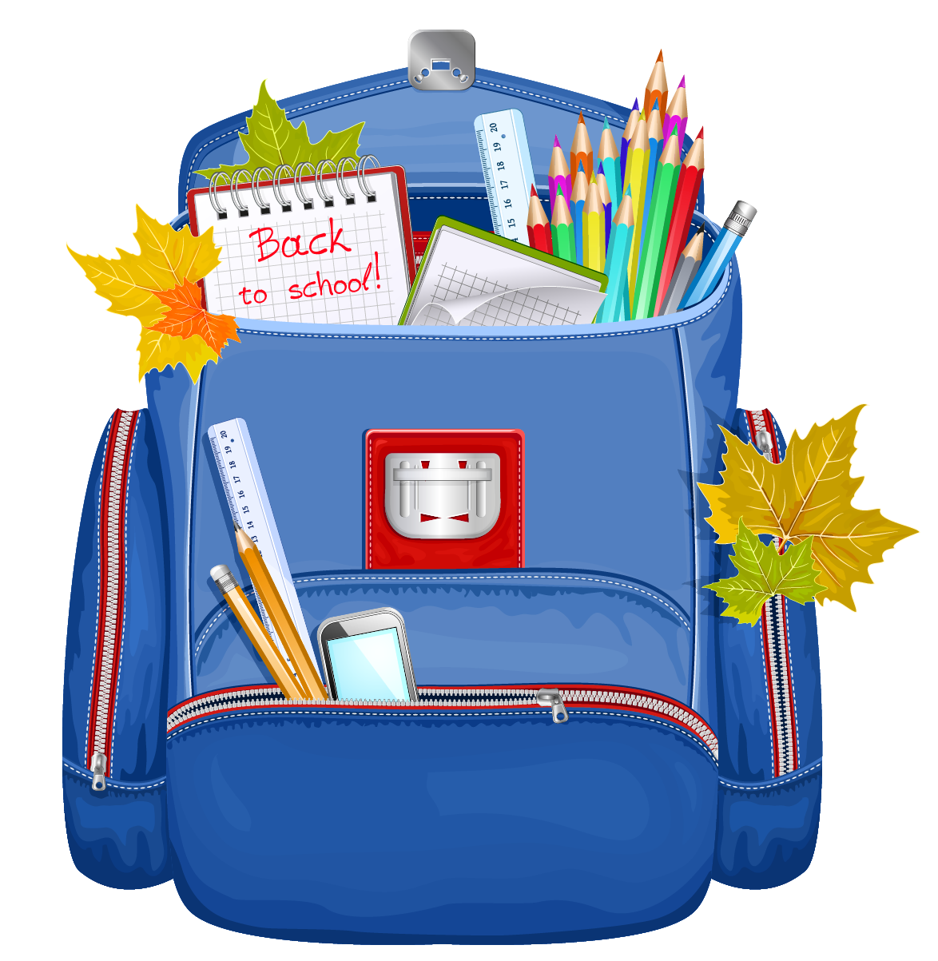
- 500 count, 3X5 index cards
- 1 - 6 - pack of post it notes (3x3)
- 1 pack of blue or black pens
- 1X 12 pack of pencils (standard #2)
- 1 box of colored pencils
- 1 Expo marker
- Several highlighters of different colors
- Pencil case to hold supplies
- Package of clear plastic page protectors
- 2 pocket folder with 3-hole punch
- Public library card
- 1-2 boxes of Kleenex (for HR/TEAM teacher)

Optional Items
- A 14” tall locker shelf (best height to separate binders from backpack and lunch)
- Calculator – Model TI-30 Xa or similar type for math
- Black, red and blue ultra thin tip Sharpies

*Note: Additional items may be requested for specific classes during the first weeks of school

